RKDF University

Ranchi, Jharkhand

MINI PROJECT / Internship REPORT

Submitted by

BASANTI KUMARI

001CSE23GT002

in partial fulfillment for the award of the degree

of

Bachelor of Engineering

in

Computer Science and Engineering

RKDF University

Ranchi, Jharkhand

An Autonomous Institution

MAY 2025

BONAFIDE CERTIFICATE

Certified that this mini project report, “Title ” is the bonafide work of

BASANTI KUMARI

001CSE23GT002

who carried out the project work under my supervision.

<<SIGNATURE OF SUPERVISOR>>

<<SIGNATURE OF HOD>>

* SHUBHANGNI DEY *

*SHUBHANGNI DEY*

SUPERVISOR

HEAD OF THE DEPARTMENT

Computer Science and Engineering

Computer Science and Engineering

RKDF University Ranchi, RKDF University Ranchi,

Jharkhand Jharkhand

#### Submitted for the Autonomous End Semester Examination Mini Project

INTERNAL EXAMINER EXTERNAL EXAMINER

<<THIS PAGE IS INTENTIONALLY LEFT BLANK>> A STUDY OF FACTORS AFFECTING THE PRINCIPLES IN DESIGNING REUSABLE COMPONENTS

ABSTRACT

*Velora Travels* is an innovative travel agency specializing in personalized travel solutions, offering tailored vacation packages, guided tours, and unique travel experiences worldwide. Known for its exceptional customer service and deep industry expertise, Velora Travels designs bespoke itineraries that cater to the individual preferences and needs of travelers. The company provides a diverse range of services, including luxury travel, adventure tourism, cultural explorations, and sustainable travel options. This report explores Velora Travels’ strategic positioning within the global travel industry, highlighting its commitment to delivering premium experiences while adapting to changing market demands and traveler expectations. The report also examines Velora Travels' competitive edge in the tourism sector, including its digital marketing strategies, customer relationship management, and partnerships with global travel providers. Additionally, it discusses the impact of global trends such as eco-tourism and post-pandemic travel behavior on the company's operations and growth potential. The report concludes with recommendations to enhance Velora Travels' offerings and strengthen its market presence in an increasingly competitive landscape.

#### ACKNOWLEDGEMENT

I am highly grateful to the Prof. (Dr.) Shuchitanshu Chatterjee, Vice Chancellor, Ram Krishna Dharmarth Foundation (RKDF) University, Ranchi and Dr. Amit Kumar Pandey, Registar, RKDF University, Ranchi for providing this opportunity to carry out the major project work.

The constant guidance and encouragement received from Ms. Shubhangni Dey, HOD CSE Department, RKDF University, Ranchi, has been of great help in carrying out the project work and is acknowledged with reverential thanks.

We would like to express our sincere gratitude to all those who contributed to the development of this report on *Velora Travels*.

First and foremost, we extend our deepest thanks to the management and team at Velora Travels for their cooperation, insightful contributions, and willingness to share valuable information about the company’s operations, strategies, and vision. Their expertise and support were instrumental in shaping the content and direction of this report.

LIST OF ABBREVIATIONS (in alphabetic order)

* **CRM** – Customer Relationship Management
* **DMC** – Destination Management Company
* **IT** – Information Technology
* **OTA** – Online Travel Agency
* **TMC** – Travel Management Company
* **VIP** – Very Important Person
* **WTTC** – World Travel & Tourism Council

#### TABLE OF CONTENTS

1.Introduction…………………………………… 7

2.Methodology and Tools…………………………8

3.Implementation………………………………… 9

3.1.Front-end……………………………………9

3.1.1.about.html…………………………… 10

3.1.2.base.html…………………………… 12

3.1.3.contact.html……………………………14

3.1.4.destination.html………………………..16

3.1.5.home.html…………………………….18

3.2 HTML (Hypertext Markup Language)

3.3 CSS (Cascading Style Sheets)

3.4 JS (Javascripts)

4.Conclusion…………………………………………19

5.Project Link…………………………………………20

INTRODUCTION

Velora Travels is a premier travel agency known for its commitment to providing personalized and unique travel experiences to a global clientele. Founded with the vision of transforming the travel industry, Velora Travels offers bespoke services ranging from luxury vacations and guided tours to adventure travel and cultural explorations. With an emphasis on customer satisfaction, the company tailors every itinerary to suit the specific needs, preferences, and desires of each traveler, ensuring an unforgettable journey.

Over the years, Velora Travels has built a reputation for excellence, partnering with world-class hotels, airlines, and local guides to deliver seamless and high-quality travel experiences. The agency's dedication to innovation and attention to detail has allowed it to remain a leader in the highly competitive travel and tourism industry.

Methodology and Tools

*Velora Travels* is based on a comprehensive analysis of both qualitative and quantitative data gathered from a variety of sources. The methodology employed combines primary research, secondary research, and analytical tools to provide a well-rounded view of the company's operations, market positioning, and growth potential. Below is a breakdown of the research methods and tools utilized:

**1. Primary Research**

Primary research involves the direct collection of data from sources such as customers, employees, and industry experts. The following methods were employed:

**2. Secondary Research**

Secondary research was conducted to gather existing information about Velora Travels and the broader travel and tourism industry. This involved reviewing:

**Company Reports and Publications**: Internal reports, financial statements, and marketing materials from Velora Travels were analyzed to understand business performance, strategic direction, and customer engagement strategies.

CONCLUSION

*Velora Travels* has firmly established itself as a leader in the travel and tourism industry, offering a broad spectrum of personalized travel services that cater to the unique needs and desires of its clientele. By focusing on luxury, tailored itineraries, and unparalleled customer service, Velora Travels continues to differentiate itself in a competitive market.

The company’s strategic use of technology, along with its partnerships with premium service providers, positions it well to capitalize on emerging trends in the travel sector, such as the growing demand for sustainable and experience-driven travel. Despite the challenges posed by a rapidly changing global landscape—such as the lingering impacts of the pandemic and shifts in consumer behavior—Velora Travels has demonstrated resilience and adaptability.

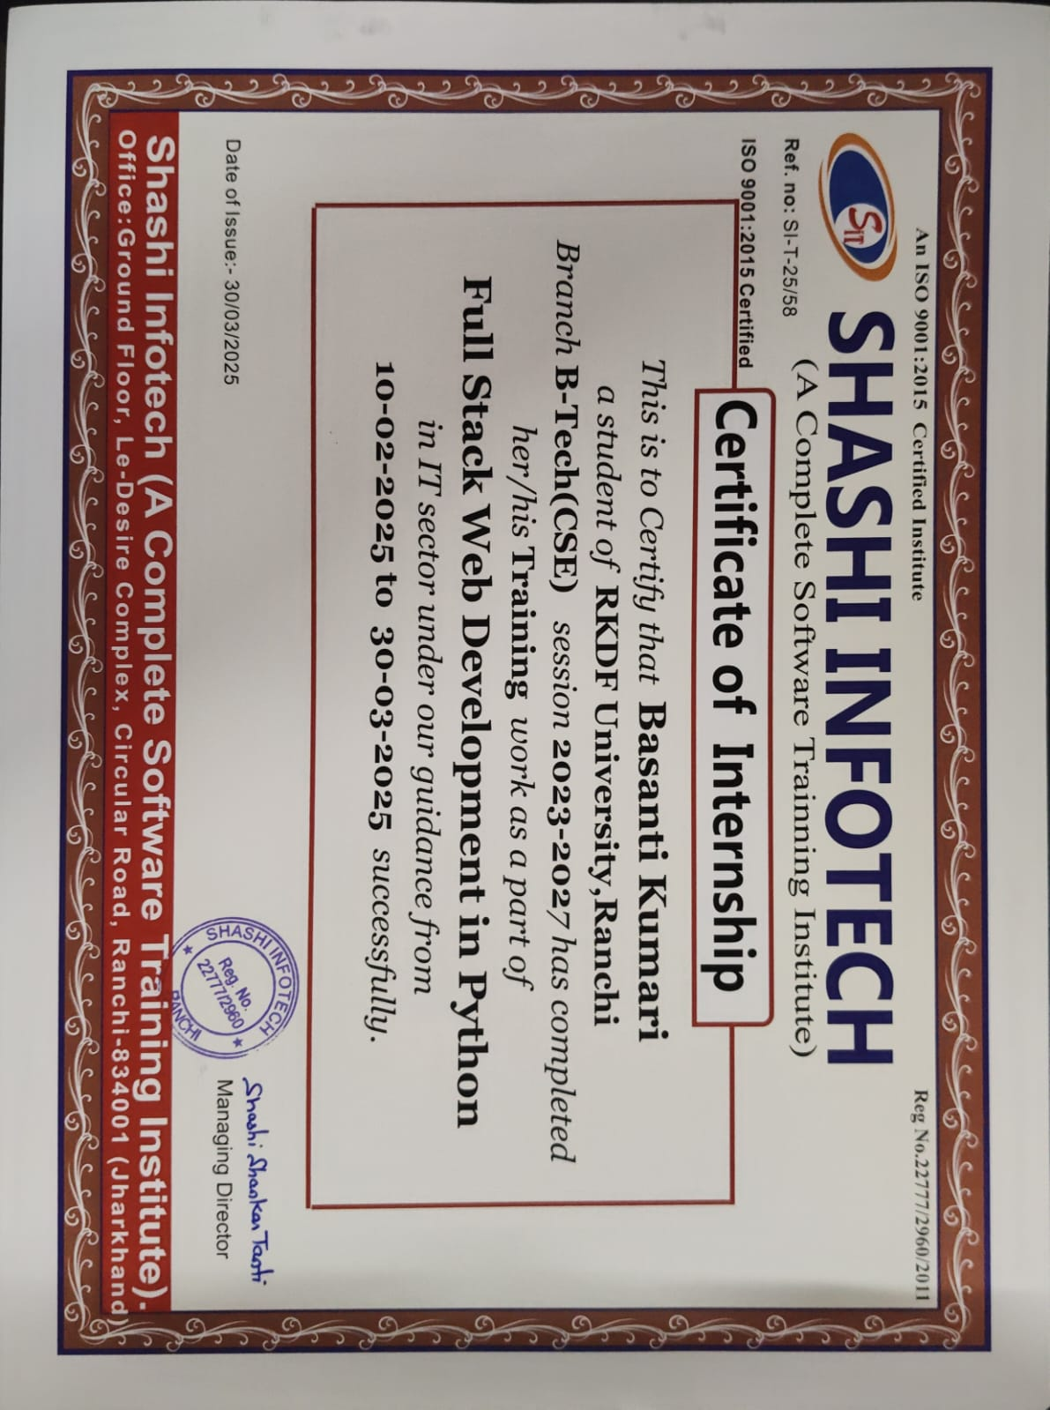

Base.html

{% load static %}

<!DOCTYPE html>

<html lang="en">

<head>

<meta charset="UTF-8">

<meta name="viewport" content="width=device-width, initial-scale=1.0">

<title>Velora Travels - {% block title %}{% endblock %}</title>

<link href="https://cdn.jsdelivr.net/npm/bootstrap@5.3.0/dist/css/bootstrap.min.css" rel="stylesheet">

<link rel="stylesheet" href="https://cdnjs.cloudflare.com/ajax/libs/font-awesome/6.4.0/css/all.min.css">

<style>

.hero-section {

background: linear-gradient(rgba(0, 0, 0, 0.5), url('https://source.unsplash.com/random/1920x600/?travel') no-repeat center center/cover);

height: 60vh;

}

.destination-card {

transition: transform 0.3s;

}

.destination-card:hover {

transform: translateY(-10px);

}

footer {

background: #1a2a36;

}

</style>

</head>

<body>

<!-- Navigation -->

<nav class="navbar navbar-expand-lg navbar-dark bg-dark sticky-top">

<div class="container">

<a class="navbar-brand" href="{% url 'velora:home' %}">

<i class="fas fa-sun"></i> Velora Travels

</a>

<button class="navbar-toggler" type="button" data-bs-toggle="collapse" data-bs-target="#navbarNav">

<span class="navbar-toggler-icon"></span>

</button>

<div class="collapse navbar-collapse" id="navbarNav">

<ul class="navbar-nav ms-auto">

<li class="nav-item">

<a class="nav-link" href="{% url 'velora:home' %}">Home</a>

</li>

<li class="nav-item">

<a class="nav-link" href="{% url 'velora:destinations' %}">Destinations</a>

</li>

<li class="nav-item">

<a class="nav-link" href="{% url 'velora:about' %}">About</a>

</li>

<li class="nav-item">

<a class="nav-link" href="{% url 'velora:contact' %}">Contact</a>

</li>

</ul>

</div>

</div>

</nav>

<!-- Content Block -->

{% block content %}{% endblock %}

<!-- Footer -->

<footer class="text-white py-5 mt-5">

<div class="container">

<div class="row">

<div class="col-md-4">

<h4>Velora Travels</h4>

<p>Creating unforgettable travel experiences since 2010. We specialize in personalized journeys to the world's most breathtaking destinations.</p>

</div>

<div class="col-md-4">

<h4>Quick Links</h4>

<ul class="list-unstyled">

<li><a href="{% url 'velora:home' %}" class="text-white">Home</a></li>

<li><a href="{% url 'velora:destinations' %}" class="text-white">Destinations</a></li>

<li><a href="{% url 'velora:about' %}" class="text-white">About Us</a></li>

<li><a href="{% url 'velora:contact' %}" class="text-white">Contact</a></li>

</ul>

</div>

<div class="col-md-4">

<h4>Contact Info</h4>

<ul class="list-unstyled">

<li><i class="fas fa-map-marker-alt me-2"></i> velora travels,ranchi,jharkhand ,India</li>

<li><i class="fas fa-phone me-2"></i> +91 3451234567</li>

<li><i class="fas fa-envelope me-2"></i> info@veloratravels.com</li>

</ul>

</div>

</div>

<hr class="bg-light">

<div class="text-center">

&copy; 2023 Velora Travels. All rights reserved.

</div>

</div>

</footer>

<script src="https://cdn.jsdelivr.net/npm/bootstrap@5.3.0/dist/js/bootstrap.bundle.min.js"></script>

</body>

</html>

About.html

{% extends 'velora/base.html' %}

{% load static %}

{% block title %}About Us{% endblock %}

{% block content %}

<!-- About Hero -->

<section class="hero-section d-flex align-items-center text-white" style="background-image: linear-gradient(rgba(0,0,0,0.5), url('https://source.unsplash.com/random/1920x600/?team'))cd">

<div class="container text-center">

<h1 class="display-1 fw-bold">About Velora Travels</h1>

<p class="lead fs-3">Your journey begins with us</p>

</div>

</section>

<!-- Our Story -->

<section class="py-5">

<div class="container">

<div class="row align-items-center">

<div class="col-md-6">

<h2 class="mb-4">Our Story</h2>

<p>Founded in 2010, Velora Travels began as a small team of passionate travelers with a simple mission: to create extraordinary travel experiences that go beyond the ordinary.</p>

<p>What started as a boutique travel agency has now grown into a trusted name in the industry, serving thousands of satisfied travelers across the globe. Our commitment to personalized service and attention to detail remains at the heart of everything we do.</p>

<p>We believe travel has the power to transform lives, broaden perspectives, and create connections that transcend borders. This belief drives us to craft journeys that are not just vacations, but life-changing experiences.</p>

</div>

<div class="col-md-6">

<img src="{% static 'velora/images/logo.jpg' %}" alt="Our Office" class="img-fluid rounded shadow">

</div>

</div>

</div>

</section>

<!-- Our Team -->

<section class="py-5 bg-light">

<div class="container">

<h2 class="text-center mb-5">Meet Our Team</h2>

<div class="row g-4">

<div class="col-md-4">

<div class="card text-center">

<img src="{% static 'velora/images/Basanti.jpg' %}" class="card-img-top" alt="Team Member">

<div class="card-body">

<h5 class="card-title">Basanti kumari</h5>

<p class="card-text">Founder & CEO</p>

<p>With 20+ years in the travel industry, Sarah's passion for exploration is infectious.</p>

</div>

</div>

</div>

<div class="col-md-4">

<div class="card text-center">

<img src="{% static 'velora/images/Lalsha.jpg' %}" class="card-img-top" alt="Team Member">

<div class="card-body">

<h5 class="card-title">Lalsha</h5>

<p class="card-text">Travel Director</p>

<p>Michael has personally visited over 70 countries and specializes in adventure travel.</p>

</div>

</div>

</div>

<div class="col-md-4">

<div class="card text-center">

<img src="{% static 'velora/images/priya.jpg' %}" class="card-img-top" alt="Team Member">

<div class="card-body">

<h5 class="card-title">Priya Sharma</h5>

<p class="card-text">Customer Experience</p>

<p>Priya ensures every client receives personalized attention and seamless service.</p>

</div>

</div>

</div>

</div>

</div>

</section>

<!-- Our Values -->

<section class="py-5">

<div class="container">

<h2 class="text-center mb-5">Our Core Values</h2>

<div class="row g-4">

<div class="col-md-4">

<div class="p-4 text-center">

<i class="fas fa-globe-americas fa-3x text-primary mb-3"></i>

<h4>Sustainable Travel</h4>

<p>We're committed to responsible tourism that benefits local communities and preserves natural environments.</p>

</div>

</div>

<div class="col-md-4">

<div class="p-4 text-center">

<i class="fas fa-heart fa-3x text-primary mb-3"></i>

<h4>Personalized Service</h4>

<p>Every journey is tailored to your unique interests, preferences, and travel style.</p>

</div>

</div>

<div class="col-md-4">

<div class="p-4 text-center">

<i class="fas fa-lightbulb fa-3x text-primary mb-3"></i>

<h4>Innovative Experiences</h4>

<p>We constantly seek new ways to create memorable and unique travel moments.</p>

</div>

</div>

</div>

</div>

Contact.html

{% extends 'velora/base.html' %}

{% block title %}Contact Us{% endblock %}

{% block content %}

<!-- Contact Hero -->

<section class="hero-section d-flex align-items-center text-white" style="background-image: linear-gradient(rgba(0,0,0,0.5), url('https://source.unsplash.com/random/1920x600/?contact'))">

<div class="container text-center">

<h1 class="display-1 fw-bold">Contact Us</h1>

<p class="lead fs-3">We'd love to hear from you</p>

</div>

</section>

<!-- Contact Form -->

<section class="py-5">

<div class="container">

<div class="row">

<div class="col-md-6">

<h2 class="mb-4">Get in Touch</h2>

<form>

<div class="mb-3">

<label for="name" class="form-label">Name</label>

<input type="text" class="form-control" id="name" required>

</div>

<div class="mb-3">

<label for="email" class="form-label">Email</label>

<input type="email" class="form-control" id="email" required>

</div>

<div class="mb-3">

<label for="subject" class="form-label">Subject</label>

<input type="text" class="form-control" id="subject" required>

</div>

<div class="mb-3">

<label for="message" class="form-label">Message</label>

<textarea class="form-control" id="message" rows="5" required></textarea>

</div>

<button type="submit" class="btn btn-primary">Send Message</button>

</form>

</div>

<div class="col-md-6">

<div class="p-4 bg-light rounded h-100">

<h3 class="mb-4">Contact Information</h3>

<ul class="list-unstyled">

<li class="mb-3">

<i class="fas fa-map-marker-alt fa-lg text-primary me-2"></i>

<strong>Address:</strong> 123 Travel Street, Wanderlust City, WC 10001

</li>

<li class="mb-3">

<i class="fas fa-phone fa-lg text-primary me-2"></i>

<strong>Phone:</strong> +1 (555) 123-4567

</li>

<li class="mb-3">

<i class="fas fa-envelope fa-lg text-primary me-2"></i>

<strong>Email:</strong> info@veloratravels.com

</li>

<li class="mb-3">

<i class="fas fa-clock fa-lg text-primary me-2"></i>

<strong>Business Hours:</strong> Mon-Fri: 9AM - 6PM, Sat: 10AM - 4PM

</li>

</ul>

<hr>

<h4 class="mt-4">Follow Us</h4>

<div class="d-flex mt-3">

<a href="#" class="me-3 text-dark"><i class="fab fa-facebook fa-2x"></i></a>

<a href="#" class="me-3 text-dark"><i class="fab fa-twitter fa-2x"></i></a>

<a href="#" class="me-3 text-dark"><i class="fab fa-instagram fa-2x"></i></a>

<a href="#" class="me-3 text-dark"><i class="fab fa-linkedin fa-2x"></i></a>

</div>

</div>

</div>

</div>

</div>

</section>

<!-- Map Section -->

<section class="py-0">

<div class="container-fluid">

<iframe src="https://www.google.com/maps/embed?pb=!1m18!1m12!1m3!1d193595.15830869428!2d-74.119763973046!3d40.69766374874431!2m3!1f0!2f0!3f0!3m2!1i1024!2i768!4f13.1!3m3!1m2!1s0x89c24fa5d33f083b%3A0xc80b8f06e177fe62!2sNew%20York%2C%20NY%2C%20USA!5e0!3m2!1sen!2s!4v1623258388182!5m2!1sen!2s" width="100%" height="450" style="border:0;" allowfullscreen="" loading="lazy"></iframe>

</div>

</section>

{% endblock %}

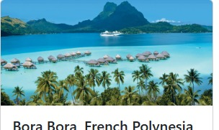

Destination.html

{% extends 'velora/base.html' %}

{% load static %}

{% block title %}Destinations{% endblock %}

{% block content %}

<!-- Destinations Hero -->

<section class="hero-section d-flex align-items-center text-white" style="background-image: linear-gradient(rgba(0,0,0,0.5), url('https://source.unsplash.com/random/1920x600/?world'))">

<div class="container text-center">

<h1 class="display-1 fw-bold">Explore Destinations</h1>

<p class="lead fs-3">Discover our handpicked travel experiences</p>

</div>

</section>

<!-- Destinations Filter -->

<section class="py-5 bg-light">

<div class="container">

<div class="row">

<div class="col-md-6 mb-3 mb-md-0">

<input type="text" class="form-control form-control-lg" placeholder="Search destinations...">

</div>

<div class="col-md-3 mb-3 mb-md-0">

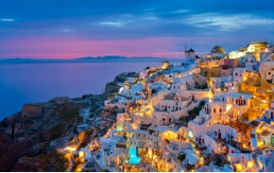

<option>Africa</option>

<option>North America</option>

<option>South America</option>

<option>Oceania</option>

</select>

</div>

<div class="col-md-3">

<select class="form-select form-select-lg">

<option selected>Travel Style</option>

<option>Beach & Relaxation</option>

<option>Adventure & Sports</option>

<option>Cultural & Historical</option>

<option>Food & Culinary</option>

<option>Luxury & Retreat</option>

</select>

</div>

</div>

</div>

</section>

<!-- Destinations List -->

<section class="py-5">

<div class="container">

<div class="row g-4">

<!-- Destination 1 -->

<div class="col-md-6 col-lg-4">

<div class="card destination-card h-100">

<img src="{% static 'velora/images/paris.jpg' %}" class="card-img-top" alt="Paris">

<div class="card-body">

<h5 class="card-title">Paris, France</h5>

<p class="card-text">The City of Light awaits with its iconic landmarks, exquisite cuisine, and romantic ambiance.</p>

<div class="d-flex justify-content-between align-items-center">

<span class="badge bg-primary">Cultural</span>

<span class="text-success fw-bold">From $1,299</span>

</div>

</div>

<div class="card-footer bg-white">

<a href="#" class="btn btn-primary w-100">View Details</a>

</div>

</div>

</div>

<!-- Destination 2 -->

<div class="col-md-6 col-lg-4">

<div class="card destination-card h-100">

<img src="{% static 'velora/images/Serengeti.jpg' %}" class="card-img-top" alt="Safari">

<div class="card-body">

<h5 class="card-title">Serengeti, Tanzania</h5>

<p class="card-text">Witness the great migration and experience Africa's breathtaking wildlife.</p>

<div class="d-flex justify-content-between align-items-center">

<span class="badge bg-success">Adventure</span>

<span class="text-success fw-bold">From $2,499</span>

</div>

</div>

<div class="card-footer bg-white">

<a href="#" class="btn btn-primary w-100">View Details</a>

</div>

</div>

<li class="page-item"><a class="page-link" href="#">3</a></li>

<li class="page-item"><a class="page-link" href="#">Next</a></li>

</ul>

</nav>

</div>

</section>

<!-- Newsletter -->

<section class="py-5 bg-primary text-white">

<div class="container text-center">

<h2 class="mb-4">Get Travel Inspiration</h2>

<p class="lead mb-4">Subscribe to our newsletter for exclusive deals and travel tips</p>

<div class="row justify-content-center">

<div class="col-md-6">

<div class="input-group">

<input type="email" class="form-control form-control-lg" placeholder="Your email address">

<button class="btn btn-dark btn-lg" type="button">Subscribe</button>

</div>

</div>

</div>

</div>

</section>

{% endblock %}

Home.html

{% extends 'velora/base.html' %}

{% load static %}

{% block title %}Home{% endblock %}

{% block content %}

<!-- Hero Section -->

<section class="hero-section d-flex align-items-center text-white">

<div class="container text-center">

<h1 class="display-1 fw-bold">Discover Your Next Adventure</h1>

<p class="lead fs-3">Experience the world with our expertly crafted travel packages</p>

<a href="{% url 'velora:destinations' %}" class="btn btn-primary btn-lg mt-3">Explore Destinations</a>

</div>

</section>

<!-- Featured Destinations -->

<section class="py-5">

<div class="container">

<h2 class="text-center mb-5">Featured Destinations</h2>

<div class="row g-4">

<div class="col-md-4">

<div class="card destination-card h-100">

<img src="{% static 'velora/images/Bali.jpg' %}" class="card-img-top" alt="Bali">

<div class="card-body">

<h5 class="card-title">Bali, Indonesia</h5>

<p class="card-text">Experience tropical paradise with pristine beaches and vibrant culture.</p>

<a href="#" class="btn btn-outline-primary">View Package</a>

</div>

</div>

</div>

<div class="col-md-4">

<div class="card destination-card h-100">

<img src="{% static 'velora/images/Santorni.jpg' %}" class="card-img-top" alt="Santorini">

<div class="card-body">

<h5 class="card-title">Santorini, Greece</h5>

<p class="card-text">White-washed buildings against the stunning backdrop of the Aegean Sea.</p>

<a href="#" class="btn btn-outline-primary">View Package</a>

</div>

</div>

</div>

<div class="col-md-4">

<div class="card destination-card h-100">

<img src="{% static 'velora/images/kyoto.jpg' %}" class="card-img-top" alt="Kyoto">

<div class="card-body">

<h5 class="card-title">Kyoto, Japan</h5>

<p class="card-text">Ancient temples, traditional gardens, and the beauty of cherry blossoms.</p>

<a href="#" class="btn btn-outline-primary">View Package</a>

</div>

</div>

</div>

</div>

</div>

</section>

<!-- Why Choose Us -->

<section class="py-5 bg-light">

<div class="container">

<h2 class="text-center mb-5">Why Choose Velora Travels?</h2>

<div class="row g-4 text-center">

<div class="col-md-4">

<div class="p-4">

<i class="fas fa-shield-alt fa-3x text-primary mb-3"></i>

<h4>Trusted Experience</h4>

<p>Over 13 years of creating unforgettable travel experiences for our clients.</p>

</div>

</div>

<div class="col-md-4">

<div class="p-4">

<i class="fas fa-hand-holding-usd fa-3x text-primary mb-3"></i>

<h4>Best Price Guarantee</h4>

<p>We offer competitive prices with no hidden fees.</p>

</div>

</div>

<div class="col-md-4">

<div class="p-4">

<i class="fas fa-headset fa-3x text-primary mb-3"></i>

<h4>24/7 Support</h4>

<p>Our travel experts are available anytime to assist you.</p>

</div>

</div>